Lesson 14

Web basics (HTML, CSS). Character Encoding.

1. **Test the website** [**www.headhunterhairstyling.com**](http://www.headhunterhairstyling.com)**, find three bugs, and record them in Google Docs. Link the document in the LMS.**

Bug 1

**[headhunter hairstylist][sending email with invalid credentials]**

Description

**Steps**

1. Type Headhunter Hairstyling | Pensacola, FL
2. Go to contacts
3. Fill out the form with invalid credentials.
4. Click: I’m not a robot.
5. Press Send.

**Expected result**

The message should not be sent.

**Actual result**

The message is sent.

**Attachments**

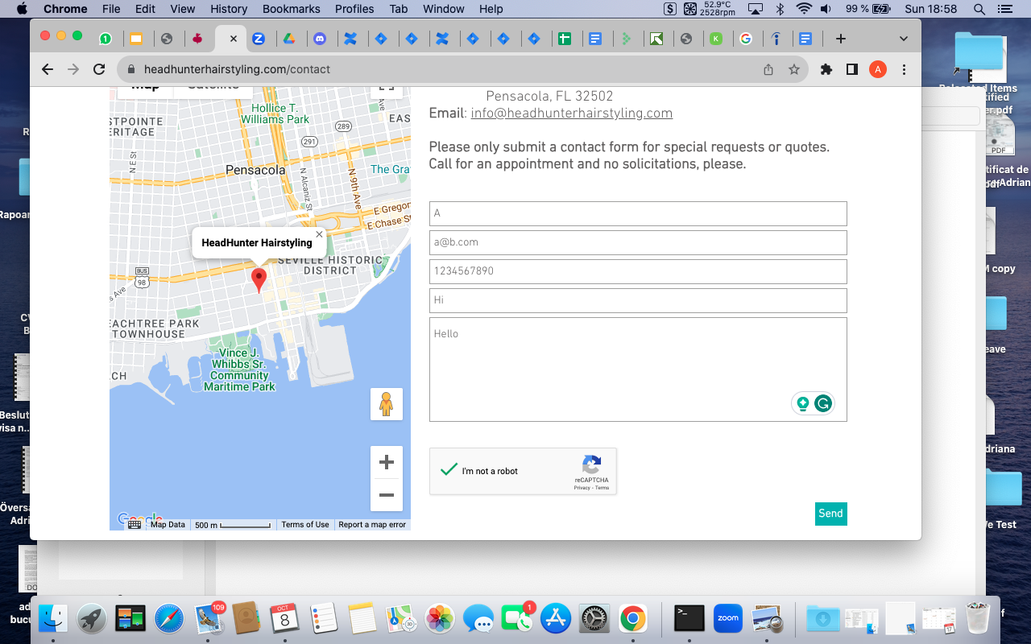

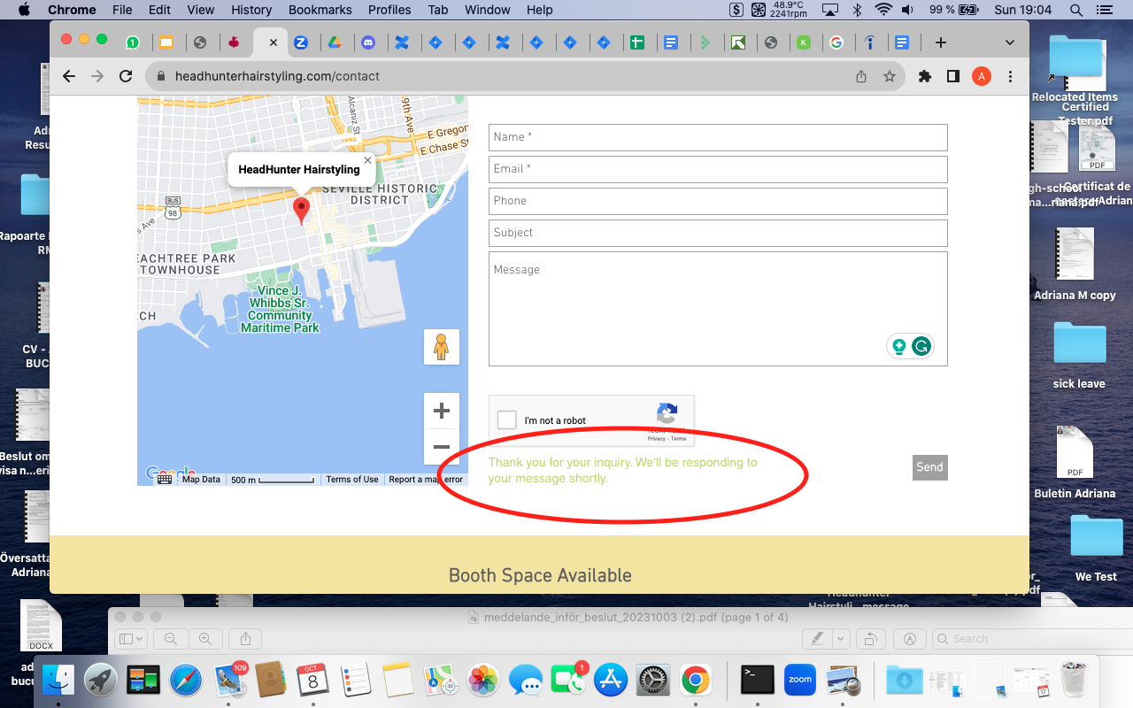

Bug 2

**[headhunter hairstylist][redirecting to another page]**

Description

**Steps**

1. Type Headhunter Hairstyling | Pensacola, FL
2. Select Stylists from the menu bar.
3. Click on the picture named ELLEN AND JEFF HUNT.

**Expected result**

The details about Ellen and Jeff Hunt should be displayed.

**Actual result**

The website is directed to Your website, your business, your future｜Wix.com

*For this exercise, I could find only two bugs, but I am still working on finding more.*

**2. Create a single HTML document with three different ways to connect styles in it:**

* **Inside a specific tag (inline)**
* **In the "HEAD" section**
* **In an external .css file**

*For this exercise, a separate file was sent in LMS.*

**3. Check the display of the created document in different browsers.**

**Briefly describe the difference in the display of elements.**

* 1. [beetroot. academy](https://beetroot.academy/)
  2. [microseniors76.com](https://microseniors76.com/)
  3. [www.tennis-warehouse.com](https://www.tennis-warehouse.com/)
  4. [www.fidelity.com](https://www.fidelity.com/)

<https://beetroot.academy/>

<meta charset="utf-8">

<https://microseniors76.com/>

<meta http-equiv="Content-Type" content="text/html; charset=iso-8859-1">

<https://www.tennis-warehouse.com/>

<meta charset="utf-8">

<https://www.fidelity.com/>

<meta http-equiv="Content-Type" content="text/html; charset=iso-8859-1">

<meta http-equiv="Content-Type" content="text/html; charset=UTF-8">